**Date:** 8th September, 2025

**Program Title:** 8-Puzzle Program - A* search

**Observation:**

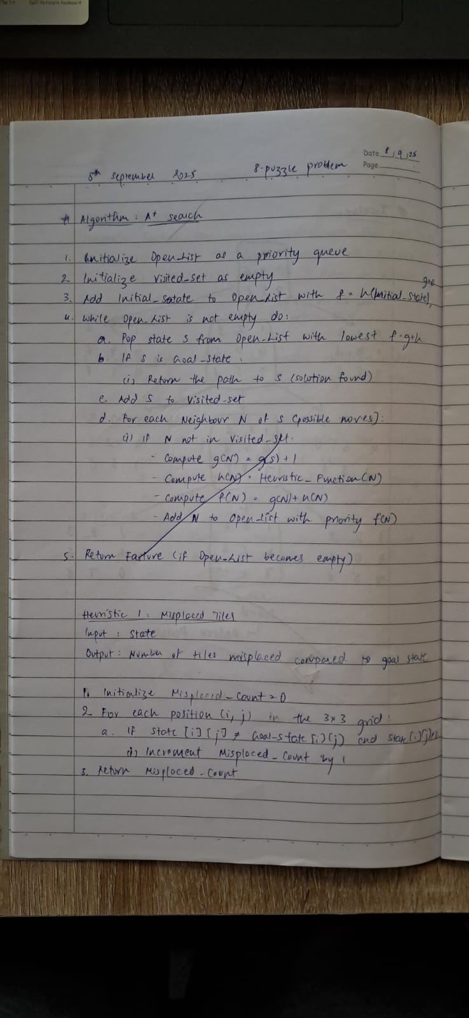

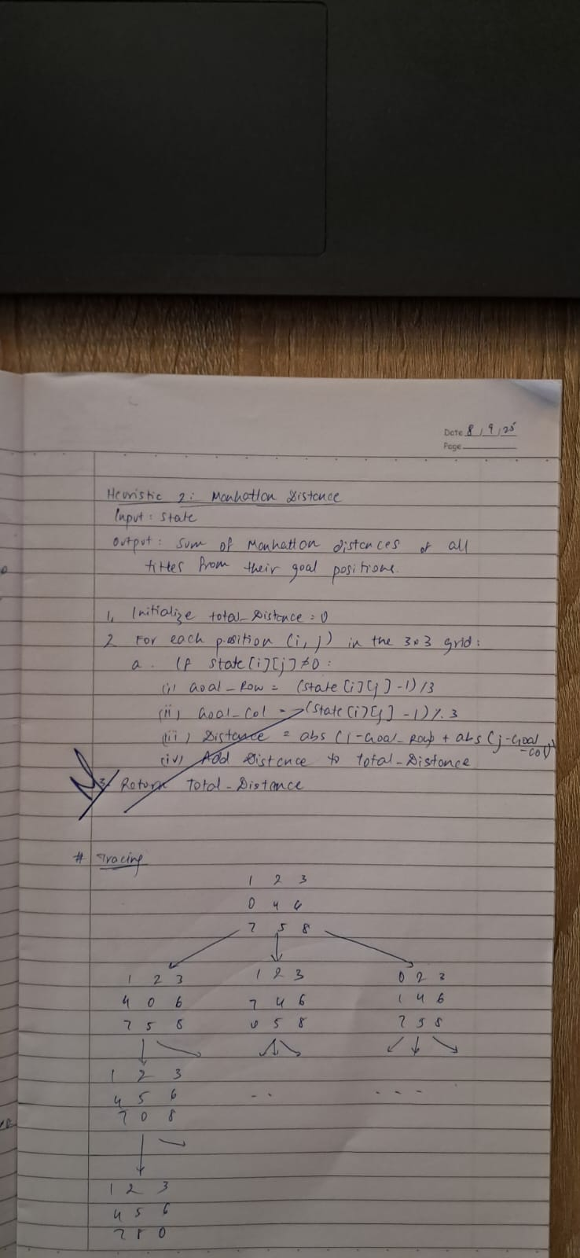

**Syntax:**

**class Node:**

**def __init__(self,data,level,fval):**

**""" Initialize the node with the data, level of the node and the calculated fvalue """**

**self.data = data**

**self.level = level**

**self.fval = fval**

**def generate_child(self):**

**""" Generate child nodes from the given node by moving the blank space**

**either in the four directions {up,down,left,right} """**

**x,y = self.find(self.data,'_')**

**""" val_list contains position values for moving the blank space in either of**

**the 4 directions [up,down,left,right] respectively. """**

**val_list = [[x,y-1],[x,y+1],[x-1,y],[x+1,y]]**

**children = []**

**for i in val_list:**

**child = self.shuffle(self.data,x,y,i[0],i[1])**

**if child is not None:**

**child_node = Node(child,self.level+1,0)**

**children.append(child_node)**

**return children**

**def shuffle(self,puz,x1,y1,x2,y2):**

**""" Move the blank space in the given direction and if the position value are out**

**of limits the return None """**

**if x2 >= 0 and x2 < len(self.data) and y2 >= 0 and y2 < len(self.data):**

**temp_puz = []**

**temp_puz = self.copy(puz)**

**temp = temp_puz[x2][y2]**

**temp_puz[x2][y2] = temp_puz[x1][y1]**

**temp_puz[x1][y1] = temp**

**return temp_puz**

**else:**

**return None**

**def copy(self,root):**

**""" Copy function to create a similar matrix of the given node"""**

**temp = []**

**for i in root:**

**t = []**

**for j in i:**

**t.append(j)**

**temp.append(t)**

**return temp**

**def find(self,puz,x):**

**""" Specifically used to find the position of the blank space """**

**for i in range(0,len(self.data)):**

**for j in range(0,len(self.data)):**

**if puz[i][j] == x:**

**return i,j**

**class Puzzle:**

**def __init__(self,size):**

**""" Initialize the puzzle size by the specified size,open and closed lists to empty """**

**self.n = size**

**self.open = []**

**self.closed = []**

**def accept(self):**

**""" Accepts the puzzle from the user """**

**puz = []**

**for i in range(0,self.n):**

**temp = input().split(" ")**

**puz.append(temp)**

**return puz**

**def f(self,start,goal):**

**""" Heuristic Function to calculate hueristic value f(x) = h(x) + g(x) """**

**return self.h(start.data,goal)+start.level**

**def h(self,start,goal):**

**""" Calculates the different between the given puzzles """**

**temp = 0**

**for i in range(0,self.n):**

**for j in range(0,self.n):**

**if start[i][j] != goal[i][j] and start[i][j] != '_':**

**temp += 1**

**return temp**

**def process(self):**

**""" Accept Start and Goal Puzzle state"""**

**print("Enter the start state matrix \n")**

**start = self.accept()**

**print("Enter the goal state matrix \n")**

**goal = self.accept()**

**start = Node(start,0,0)**

**start.fval = self.f(start,goal)**

**""" Put the start node in the open list"""**

**self.open.append(start)**

**print("\n\n")**

**while True:**

**cur = self.open[0]**

**print("")**

**print(" | ")**

**print(" | ")**

**print(" \\\'/ \n")**

**for i in cur.data:**

**for j in i:**

**print(j,end=" ")**

**print("")**

**""" If the difference between current and goal node is 0 we have reached the goal node"""**

**if(self.h(cur.data,goal) == 0):**

**break**

**for i in cur.generate_child():**

**i.fval = self.f(i,goal)**

**self.open.append(i)**

**self.closed.append(cur)**

**del self.open[0]**

**""" sort the opne list based on f value """**

**self.open.sort(key = lambda x:x.fval,reverse=False)**

**puz = Puzzle(3)**

**puz.process()**

**Output:**

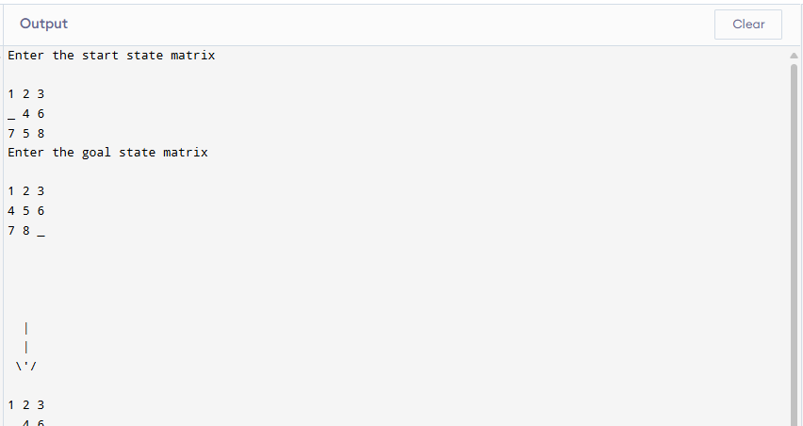

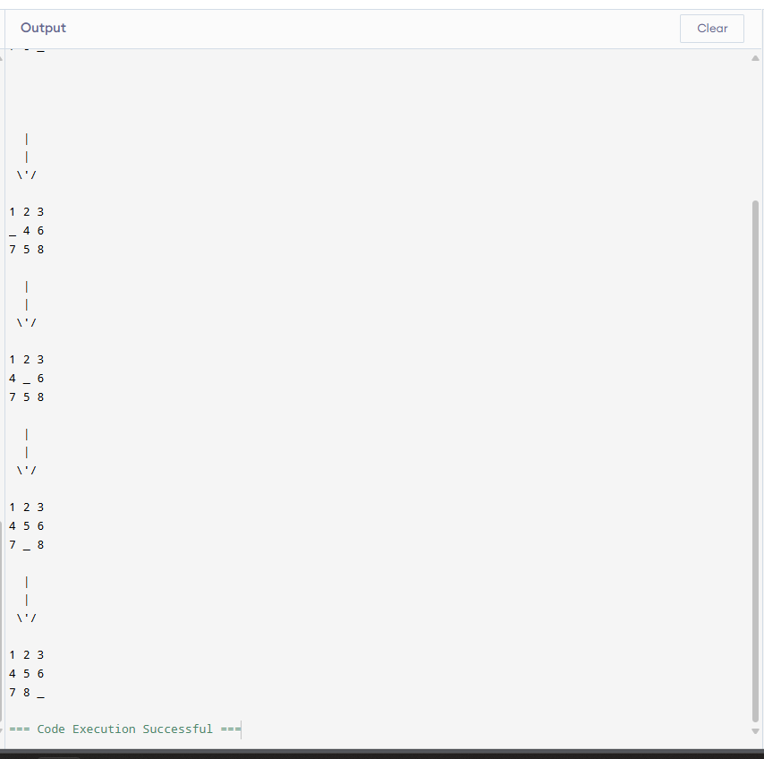

**Tracing:**

